**I. Contents:**

II. Objectives

III. Experimental design

IV. Installation materials

V. Personal protective equipment

VI. Procedure

VII. Corresponding documentation

VIII. References

**II. Objective:**To measure soil pore space carbon dioxide (CO2) and methane (CH4) concentrations throughout the soil profile within each TEMPEST treatment plot. This protocol describes the gas well experimental design, installation, and data collection procedures.

**III. Experimental design:** Five gas well nests have been installed within each TEMPEST treatment plot to quantify depth-specific soil air [CO2] and [CH4]. Target depths = 5-10, 15-20, 30-35, and 45-50 cm below the soil surface. Gas well nests are co-located with continuous measurements of soil temperature, water content, and electrical conductivity (TEROS 12 sensors, installed at 5, 15, and 30 cm below the soil surface) and period measurements of soil porewater chemistry (lysimeters installed 15 cm below the soil surface). Nest design and locations are shown below:

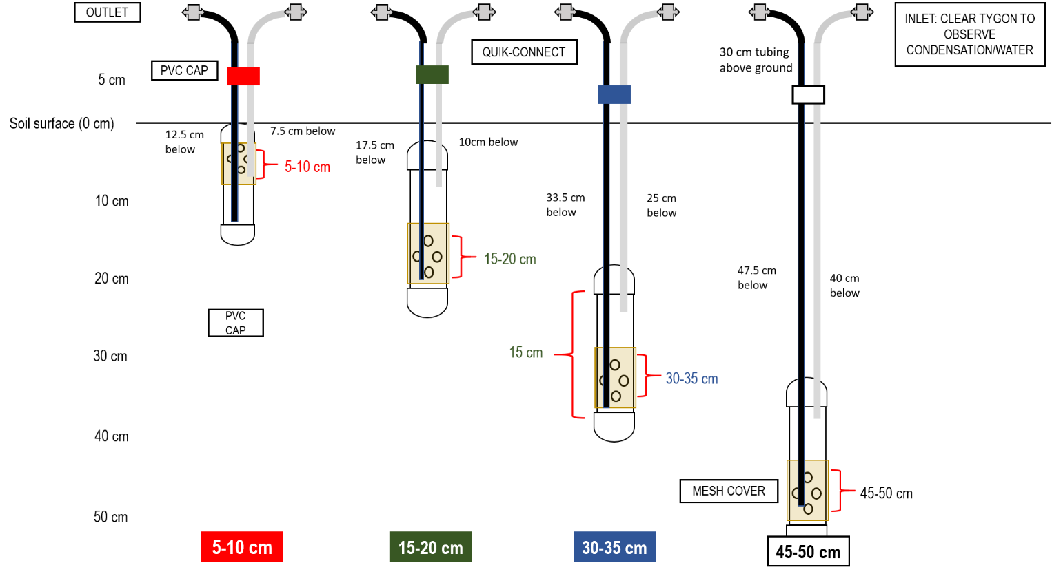

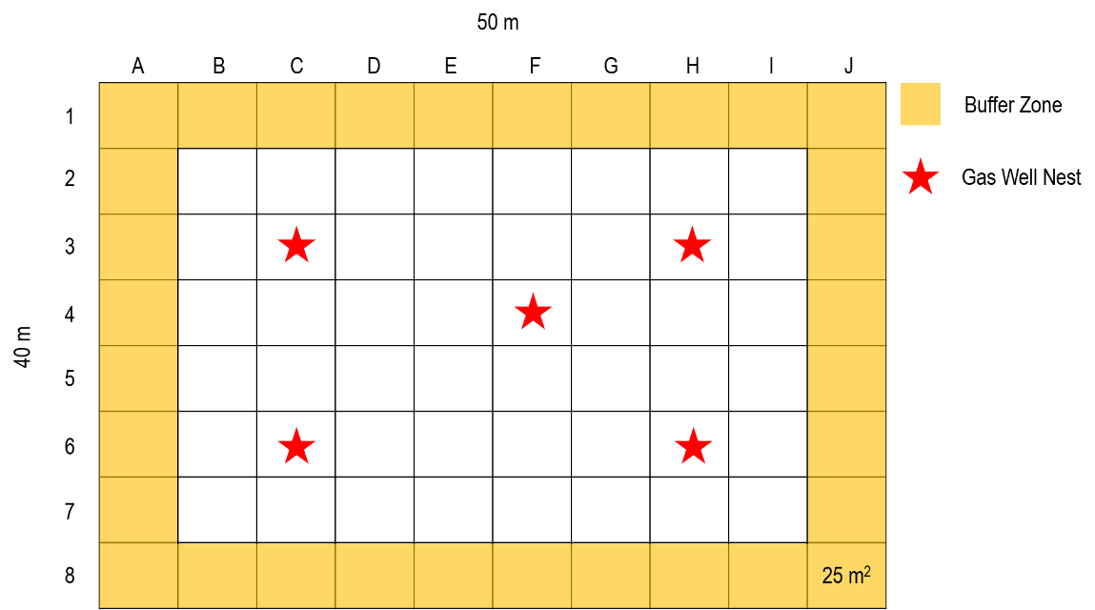

Note: The gas well locations are the same in each TEMPEST treatment plot: C3, C6, F4, H3, and H6.

**IV. Installation and measurement materials:**

*Stage 1 – gas well construction:*

* 9-10 m of 1” PVC
* 120 1” PVC caps
* ¼” tubing – we used a combination of opaque and [tygon](https://www.mcmaster.com/tygon-tubing/) tubing
* 60 one-way polycarbonate [stopcocks](https://www.shop-esp.com/1-way-Stop-ValvebrPolycarbonate-P940.aspx?gclid=Cj0KCQjwv7L6BRDxARIsAGj-34rd1KuSkVvQ7I1ddteqJkkYVraJ-aojS8WFzQj8tofbYZ37Lxv-n9caAsJKEALw_wcB)
* 45 µm mesh – can be different size, this was available
* Duct tape
* Drill
* PVC cutter

*Stage 2 – gas well installation:*

* 2” soil auger
* Drill
* Tarp
* Folding ruler
* Plant stand – or anything that organizes the tubing
* Flagging to mark nest location (plastic only! No metal)

*Stage 3 – gas well measurement:*

* Los Gatos ultraportable greenhouse gas analyzer
* Los Gatos battery
* Los Gatos tablet
* Los Gatos tubing equipped with inline filter
* Water trap
* Quick connects

**V. Personal protective equipment:**

Close-toed shoes and long pants are required at all times while working at the TEMPEST site. Work gloves are also recommended for this installation portion of this protocol.

**VI. Procedure:**

*Stage 1 – gas well construction:*

1. Cut 1” PVC into 15-cm sections
2. Drill 20 holes in the bottom 5-cm section of the PVC
3. Drill tubing holes in the PVC cap
4. Glue the inlet tubing (tygon) into the cap so that it is 5 cm from the top of the gas well
5. Glue the outlet tubing (opaque) into the cap so that it is 14 cm from the top of the gas well
6. Glue the PVC cap and bottom to gas well
7. Cover the sampling holes with mesh and use duct tape to keep it in place

Note: it is very important that the sampling holes are located at the bottom of the well and that the inlet tubing is no more than 5 cm from the top of the well. This design allows for the measurement of soil gas content even when the well is under water and circulates the sample headspace throughout the well.

*Stage 2 – gas well installation:*

1. Use the drill and 2” soil auger to dig a hole approximately 4-cm below the desired well depth (extra 4 cm accounts for the PVC cap)
2. Install gas well at target depth
3. Backfill soil into hole, packing it to similar compact-ness to maintain natural water flow around the sensor
4. Use plant stand to organize gas well sampling lines
5. Close sampling lines to atmosphere with one-way stopcocks

*Stage 3 – gas well measurement:*

1. Connect battery to LGR analyzer
2. Turn on the power
   1. Should hear the analyzer turn on after 1-2 minutes
3. Allow instrument to warm up for approximately 10 minutes
4. Connect inlet (RED) and outlet tubing to LGR analyzer
   1. Outlet port is located beneath battery connection
5. Connect the LGR inlet (RED) to gas well inlet (tygon/clear)
   1. **Be sure that the water trap is on the inlet**
6. Connect the LGR outlet to the gas well outlet (opaque)
7. Connect tablet to ZYXEL network
8. Open VNC Viewer
9. Select “Display” twice to view CO2 and CH4 graphs
10. Change graph display to CH4, DRY and CO2, DRY – instrument adjusts for humidity/water vapor
    1. Cannot change the y-axis scale, so it may be difficult to see concentration changes
    2. Collects data every 2 seconds
11. Always measure shallowest well first then increase in depth
    1. Moves from the lowest to highest concentration well
12. Record gas well ID and measurement start time
    1. Make sure you are using the time on the tablet – not your watch
13. 5-minute measurement time or until concentration stabilizes
14. Allow the LGR sampling lines to flush between nests – only needs a few minutes
15. Be sure to close the gas well inlet and outlet to the atmosphere when finished
16. Collect data:
    1. Plug USB into LGR analyzer
    2. Select “Files”
    3. Sort files by “Date”
    4. Select “Mount USB”
    5. Use table mouse to copy the entire folder for the day to USB drive
    6. Select “Unmount USB”
17. When finished with measurements, select “Exit” on tablet
    1. Should hear analyzer turn off
18. Turn off power
19. Be sure to place battery and tablet back on charger

**VII. Corresponding documentation:** N/A

**VIII. Reference materials:** N/A